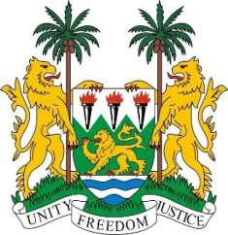
SIERRA LEONE
24th Session of the UPR

MOZAMBIQUE

19 January 2016

Mr President,

Sierra Leone warmly welcomes the high-level delegation of Mozambique and thanks them for their oral update.

My delegation commends the progress made since their first review including the enactment in 2015 of a new Penal Code.

Similarly, we note with interest the high percentage of implemented recommendations accepted during its last review, as well as progress made in implementing various policies, including the National Action Plan for Children, and the provision of universal access to Antiretroviral Treatment for HIV pregnant women.

Sierra Leone would however encourage Mozambique to further promote the rights of women, especially with regard to ensuring their inheritance and succession rights by enacting the Law on Succession.

Furthermore, the government should take concrete measures to improve the quality of education by reforming its education system.

Sierra Leone has these recommendations:

- Harmonize laws and revise customary practices with a view to preventing child, early and forced marriage.
- More effectively address and combat domestic violence as perpetuated against women and the elderly.
- Consistently address and prosecute incidents of violence against persons with albinism and take measures to comprehensively protect their human rights.
- Submit overdue reports to the relevant treaty bodies.

To conclude, Sierra Leone wishes Mozambique a successful review process.

Thank you, Mr President.

